Universidade Federal de Pernambuco
Centro de Informática

Reuso Estratégico com Linhas de Produto de Software

Projeto – Parte 2
SmartHome
Carlos Eduardo Pontual
Fernanda d’Amorim
Leopoldo Texeira

17/04/2008

[

2. Feature Model
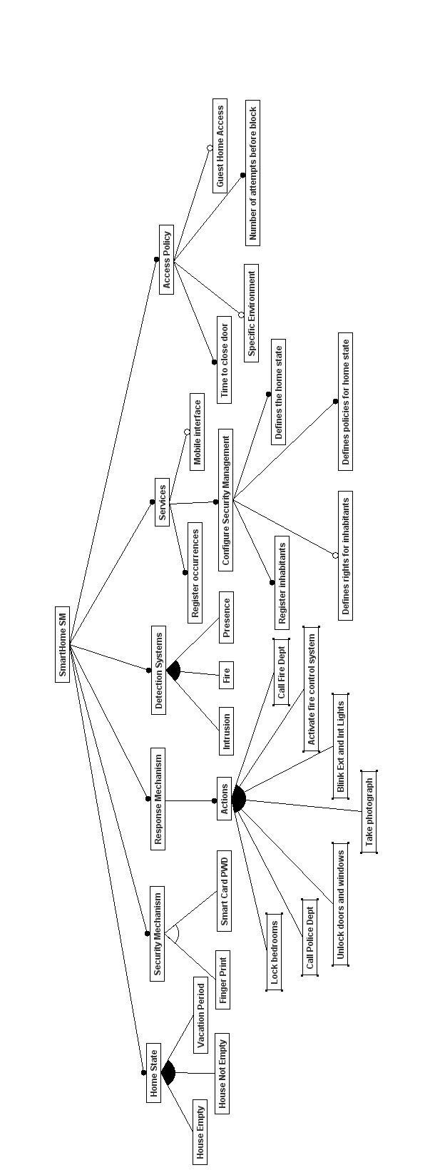

2. Product Configurations
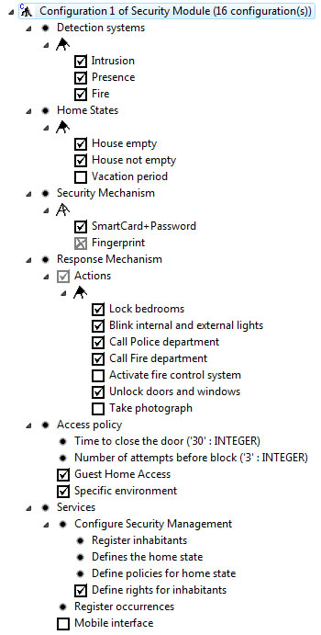
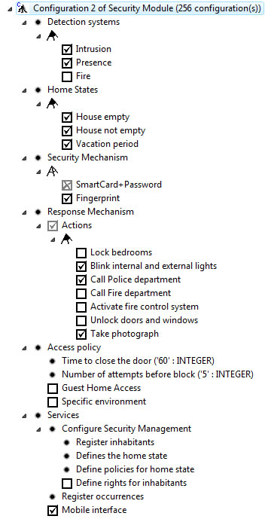
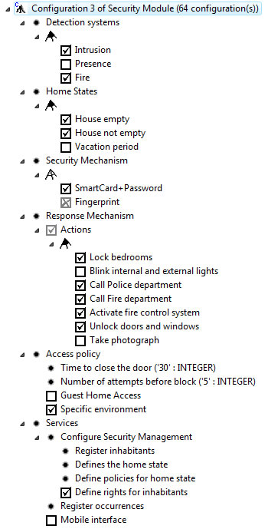
3. SPL Use Case Model – Using VM as Crosscutting Technique

UC01- Configure Security Management
Description: This use case allows the owner of a smart home to configure the security module behavior. Several characteristics may be configured, such as access policies, presence information, and so on.
Scenario SC01 - Register Inhabitant
Description: This scenario allows the owner of the system to register new home inhabitants. In this way, the policies for entrance in the home are applied for them.
ID: UC01/RI

From step: START
To step: PW.1,FP.1

ID | User Action | System Response
RI.1 | The home owner selects the register inhabitant option in the security configuration menu. | The inhabitant personal form is displayed.

Description: Security Mechanism – Smart card + Password
ID: UC01/PW

From step: RI.1
To step: RA.1

ID | User Action | System Response
PW.1 | The home owner fills in the inhabitant personal form and selects the proceed option. | The system requires the inhabitant password (and password confirmation) for getting access to the home..
PW.2 | The new inhabitant fills in the password (and confirmation password) for home access. | The system requests the home owner configuration password.

Description: Register Action
ID: UC01/RA

From step: PW.2, FP.1
To step: END

ID | User Action | System Response
RA.1 | The home owner fills in the configuration password and selects the proceed option. | The system register the new inhabitant, allowing he (she) to access the smart house.

Description: Security Mechanism – Finger Print
ID: UC01/FP

From step: RI.1
To step: RA.1

ID | User Action | System Response
FP.1 | The home owner fills in the inhabitant personal form and selects the proceed option. | The system requires the inhabitant finger print to capture it.
FP.2 | The new inhabitant put your finger in the finger print capture device. | The system get the new inhabitant finger print information and asks the home owner to proceed.
FP.3 | The home owner selects the proceed option. | The system requests the home owner configuration password.

Scenario SC02 – Defines the home state
Description: This scenario allows the owner of smart home to change the house state.
ID: UC01/DH

From step: START
To step: END

ID | User Action | System Response
DH.1 | The home owner selects the set home state option in the security configuration menu. | The home state form is displayed, requiring the selection of one of the available <homeState>
DH.2 | The home owner selects one of the configured states. | The system requests the home owner configuration password.
DH.3 | The home owner fills in the configuration password and selects the proceed option. | The system updates the home state and activates the corresponding intrusion and presence policies.

Scenario SC03 – Define policies for home state
Description: This scenario allows the owner of smart home to change the policies for a specific home state.
ID: UC01/DP
From step: START
To Step: END

ID | User Action | System Response
DP.1 | The home owner selects the configure policies for home state option in the security configuration menu. | The home state form is displayed, requiring the selection of one of the available <homeState>
DP.2 | The home owner selects one of the available states. | The home state policy form is displayed, requiring: list of notification numbers, audio message, and text message.
DP.3 | The home owner fills in the requested information. | The system requests the home owner configuration password.
DP.4 | The home owner fills in the configuration password and selects the proceed option. | The system updates the home state and activates the corresponding intrusion and presence policies.

SC04 – Define rights for inhabitants
Description: This scenario allows the owner of smart home to change the rights for registered inhabitants, such as defining which home environments an inhabitant can configure access.
ID: UC01/DR

From step: START
To Step: END

ID | User Action | System Response
DR.1 | The home owner selects the configure rights for inhabitant option in the security configuration menu. | The select an inhabitant form is displayed, requiring the selection of one of the registered inhabitants.
DR.2 | The home owner selects one of the registered inhabitants. | The inhabitant rights form is displayed, requiring the home owner to inform if the inhabitant is able to entering in the house and which environments of the house the inhabitant can change the access control.
DR.3 | The home owner fills in the requested information. | The system requests the home owner configuration password.
DR.4 | The home owner fills in the configuration password and selects the proceed option. | The system updates the inhabitant rights and activates the corresponding policies.

UC02 – Request Access to Home
Scenario SC01 – Request Access to Home

Description: Request access to home using smart card + password
ID: UC02/RS

From step: START
To step: END

ID | User Action | System Response
RS.1 | The inhabitant request access to the home at the main entrance. | The system requests to the user to pass the smart card.
RS.2 | The inhabitant pass the smart card in the card reader. | The system requests to the user the password to access the smart home.
RS.3 | The inhabitant informs the access password. | The system verifies that the password is valid for the registered inhabitant.
RS.4 | - | The system displays the message of success login.
 |  | The system opens the front door and register the occurrence.
 |  | After <timeCloseDoor> seconds, the front door is closed.

Exceptional flow

Description: Request access to home using smart card + password – invalid password.

ID: UC02/IP

From step: RS.2
To step: END

ID | User Action | System Response
IP.1 | The inhabitant informs the access password. | The system verifies that the password is not valid for the registered inhabitant.
IP.2 | - | The system registers the occurrence.
 |  | The system request to the user to pass the smart card again, returning to the previews step. If the number of attempts is greater than <numberAttempts>, the system sends an warning message for the home owner and blocks the inhabitant to enter into the house.

Scenario SC02 – Request Access to Home

Description: Request access to home using fingerprint
ID: UC02/RF

From step: START
To step: END

ID | User Action | System Response
RF.1 | The inhabitant request access to the home at the main entrance. | The system requests the user to put your finger in the finger print reader.
RF.2 | The inhabitant put his (her) finger in the finger print reader. | The system recongnizes the finger print information as a registered inhabitant.
RF.3 | - | The system displays the message of success login.
 |  | The system opens the front door and register the occurrence.
 |  | After <timeCloseDoor> seconds, the front door is closed.

Exceptional flow

Description: Request access to home using fingerprint, invalid password
ID: UC02/RI

From step: RF.1
To step: END

ID | User Action | System Response
RI.1 | The inhabitant put his (her) finger in the finger print reader. | The system does not recongnizes the finger print information as a registered inhabitant.
RI.2 | - | The system displays the message reporting that the inhabitant was not recognized.
RI.2 | - | The system register the occurrence, taking a photograph of the not recognized inhabitant.
RI.2 | - | A warning message is sent to the home owner.

Scenario SC03 – Guest Request Access to Home

Description: This scenario allows a guest to enter into the house, however, the house is empty. This scenario is useful in cases where the home owner family is traveling but a employee, a relative or a close friend needs to enter into the house.

ID: UC02/GR

From step: START
To step: END

ID | User Action | System Response
GR.1 | The guest request access to the home at main entrance. | The system requests the guest name and the reason for entering in the house.
GR.2 | The guest fills in the requested information. | The system takes a guest photograph and sends one message to the home owner mobile device.
GR.2 | The guest fills in the requested information. | The system asks for the guest to wait a few minutes.
GR.3 | The home owner <mobileInterface> authorizes the guest to enter into the house. | The system displays the message of authorized access.
 |  | The system opens the front door and register the occurrence.
 |  | After <timeCloseDoor>, the front door is closed.

Exceptional Flow

Description: The guest is not authorized to enter the house
ID: UC02/GD

From step: GR.2
To step: END

ID | User Action | System Response
GD.1 | The home owner do not authorize the guest to enter into the house. | The system displays the message of unauthorized access.
GD.1 |  | The system asks the guest to place a call to the home owner. The scenario finishes.

UC03 – Configure Access to Specific Environment
Scenario SC01 – Main flow of events

Description: The inhabitant has privileges
ID: UC03/HP

From step: START
To step: END

ID | User Action | System Response
HP.1 | The inhabitant selects the configure access rule for specific environment option in the security configuration menu. | The system requests to the user to select a specific environment (room, office, bedroom, kitchen) of the smart home.
HP.2 | The inhabitant selects one of the available environments of the smart home. | The system checks that the inhabitant is able to change the access rule for the selected environment.
HP.3 | The inhabitant select the access rule to be applied in the selected environment. The valid access rules are: restricted and unrestricted. | The system requests the inhabitant password.
HP.4 | The inhabitant fills in the password and selects the proceed option. | The system applies the policy for the selected environment.

Exceptional flow

Description: the inhabitant does not have privileges
ID: UC03/NP

From step: HP.1
To step: END

 | User Action | System Response
NP.1 | The inhabitant selects one of the available environments of the smart home. | The system checks that the inhabitant is not able to change the access rule for the selected environment.
NP.2 |  | The system presents to the user the appropriated message and the scenario finishes.

UC04 – Intrusion Detection
Description: This use case is responsible for catching any attempt to intrude the smart home. Several events are used to characterize this kind of attempt, such as window or door braking.
Scenario SC01 – Detect an attempt of intrude. The house is not empty.
Description: This scenario describes the behavior that is performed when an attempt to intrude event occurs and the house is not empty.

ID: UC04/IE

From step: START
To step: LB.1,TL.1, SM.1

ID | Actor Action | System Response
IE.1 | The presence sensor identifies that someone is trying to intrude into the smart home. This might be deduced by observing any suspect event (forcing or braking) in external doors and windows. | The system emits the configured internal sound alarm.
IE.2 |  | The system places a call to the police department.

Description: Lock the bedroom action
ID: UC04/LB

From step: IE.2
To step: TL.1
ID | Actor Action | System Response
LB.1 |  | The system locks the access to the bedrooms.

Description: Turn lights on action
ID: UC04/TL

From step: IE.2, LB.1
To step: END

ID | Actor Action | System Response
TL.1 |  | The system turns on external and internal lights.

Scenario SC02 – Detect an attempt of intrude. The house is empty.
Description: This scenario describes the behavior that is performed when an attempt to intrude event occurs and the house is in the empty state
ID: UC04/EA
From step: IE.1
To step: IE.2

ID | Actor Action | System Response
EA.1 |  | The system emits the configured external sound alarm.

Description: Send Message Action
ID: UC04/SM

From step: IE.1
To step: TL.1

ID | Actor Action | System Response
SM.1 |  | The system sends a message to the home owner

UC05 – Presence Detection
Description: This use case is responsible for catching presence information when the house should be empty.
Scenario SC01 – Detect presence when the house is empty
Description: This scenario describes the behavior that is performed when presence is detected and the house should be empty.
ID: UC05/PD

From step: START
To step: END

ID | Actor Action | System Response
PD.1 | The presence sensor identifies some presence information. | The system emits the configured external sound alarm.
 | The presence sensor identifies some presence information. | The system places a call to the police department and send a message to the home owner.
 | The presence sensor identifies some presence information. | The system turns on external and internal lights.

UC06 – Fire Detection
Description: This use case is responsible for identifying presence of fire or smoke inside the home.
Scenario SC01 – Detect smoke or suspect high temperature inside the smart home.
Description: This scenario describes the behavior that is performed when fire is detected.
ID: UC06/FD
From Step: START
To Step: END
ID | Actor Action | System Response
FD.1 | The fire sensor identifies a possible fire occurrence (based on smoke or temperature elevation). | The system emits the configured internal sound alarm.
FD.1 |  | The system places a call to the fireguard department and sends a message to the home owner.
FD.1 |  | The system unlocks all doors and windows. [FireControlSystem]

Description: Activate fire control system
ID: UC06/FC
From Step: [FireControlSystem]
To Step: END
ID | Actor Action | System Response
FC.1 | - | The system sends a message to the fire control system, which performs its configured reactive actions.

Configuration Knowledge

Expression | Required Artifacts
Register Inhabitant | UC01/RI, UC01/RA
(Register inhabitant) and (smartcard+pwd) | UC01/PW
(Register inhabitant) and (finger print) | UC01/FP
Defines the home state | UC01/DH(parametrizado)
Defines police for home state | UC01/DP(parametrizado)
Defines rights for inhabitants | UC01/DH
(Request Access to home) and (smartcard+pwd) | UC02/RS(parametrizado), UC02/IP(parametrizado)
(Request Access to home) and (finger print) | UC02/RF(parametrizado), UC02/RI
Guest home access | UC02/GR(parametrizado),UC02/GD
Specific Environment | UC03/HP, UC03/NP
Intrusion | UC04/IE, UC04/EA, UC04/SM
(Intrusion) and (lock bedrooms) | UC04/LB
(Intrusion) and (blink int. and ext. lights) | UC04/TL
Presence | UC05/PD
Fire | UC06/FD
(Fire) and (activate fire control system) | UC06/FC

