**Playlist (10 talks): How to live with robots**

* [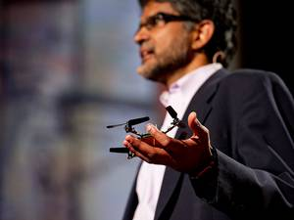16:46](https://www.ted.com/talks/vijay_kumar_robots_that_fly_and_cooperate" \t "_blank)

[Vijay Kumar](https://www.ted.com/speakers/vijay_kumar) [Robots that fly ... and cooperate](https://www.ted.com/talks/vijay_kumar_robots_that_fly_and_cooperate)

In his lab at Penn, Vijay Kumar and his team build flying quadrotors, small, agile robots that swarm, sense each other, and form ad hoc teams — for construction, surveying disasters and far more.

[Watch later](https://www.ted.com/session/new) · [363 comments](https://www.ted.com/talks/vijay_kumar_robots_that_fly_and_cooperate)

* [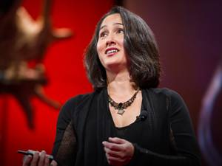14:04](https://www.ted.com/talks/cynthia_breazeal_the_rise_of_personal_robots)

[Cynthia Breazeal](https://www.ted.com/speakers/cynthia_breazeal) [The rise of personal robots](https://www.ted.com/talks/cynthia_breazeal_the_rise_of_personal_robots)

As a grad student, Cynthia Breazeal wondered why we were using robots on Mars, but not in our living rooms. The key, she realized: training robots to interact with people. Now she dreams up and builds robots that teach, learn — and play. Watch for amazing demo footage of a new interactive game for kids.

[Watch later](https://www.ted.com/session/new) · [178 comments](https://www.ted.com/talks/cynthia_breazeal_the_rise_of_personal_robots)

* [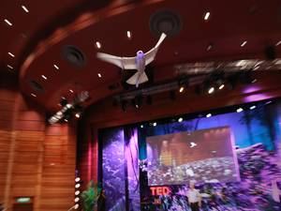6:19](https://www.ted.com/talks/a_robot_that_flies_like_a_bird)

[Markus Fischer](https://www.ted.com/speakers/markus_fischer) [A robot that flies like a bird](https://www.ted.com/talks/a_robot_that_flies_like_a_bird)

Plenty of robots can fly — but none can fly like a real bird. That is, until Markus Fischer and his team at Festo built SmartBird, a large, lightweight robot, modeled on a seagull, that flies by flapping its wings. A soaring demo fresh from TEDGlobal 2011.

[Watch later](https://www.ted.com/session/new) · [424 comments](https://www.ted.com/talks/a_robot_that_flies_like_a_bird)

* [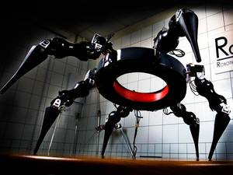15:55](https://www.ted.com/talks/dennis_hong_my_seven_species_of_robot)

[Dennis Hong](https://www.ted.com/speakers/dennis_hong) [My seven species of robot](https://www.ted.com/talks/dennis_hong_my_seven_species_of_robot)

Dennis Hong introduces seven award-winnning, all-terrain robots — like the humanoid, soccer-playing DARwIn and the cliff-gripping CLIMBeR — all built by his team at RoMeLa, Virginia Tech. Watch to the end to hear the five creative secrets to his lab's incredible technical success. (Filmed at TEDxNASA.)

[Watch later](https://www.ted.com/session/new) · [177 comments](https://www.ted.com/talks/dennis_hong_my_seven_species_of_robot)

* [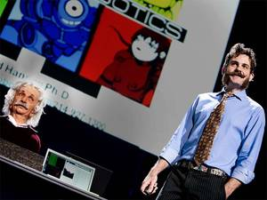4:57](https://www.ted.com/talks/david_hanson_robots_that_relate_to_you)

[David Hanson](https://www.ted.com/speakers/david_hanson) [Robots that "show emotion"](https://www.ted.com/talks/david_hanson_robots_that_relate_to_you)

David Hanson's robot faces look and act like yours: They recognize and respond to emotion, and make expressions of their own. Here, an "emotional" live demo of the Einstein robot offers a peek at a future where robots truly mimic humans.

[Watch later](https://www.ted.com/session/new) · [162 comments](https://www.ted.com/talks/david_hanson_robots_that_relate_to_you)

* [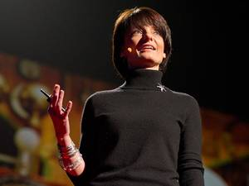25:01](https://www.ted.com/talks/regina_dugan_from_mach_20_glider_to_humming_bird_drone)

[Regina Dugan](https://www.ted.com/speakers/regina_dugan) [From mach-20 glider to hummingbird drone](https://www.ted.com/talks/regina_dugan_from_mach_20_glider_to_humming_bird_drone)

"What would you attempt to do if you knew you could not fail?" asks Regina Dugan, then director of DARPA, the Defense Advanced Research Projects Agency. In this breathtaking talk she describes some of the extraordinary projects — a robotic hummingbird, a prosthetic arm controlled by thought, and, well, the internet — that her agency has created by not worrying that they might fail. (Followed by a Q&A with TED's Chris Anderson)

[Watch later](https://www.ted.com/session/new) · [489 comments](https://www.ted.com/talks/regina_dugan_from_mach_20_glider_to_humming_bird_drone)

* 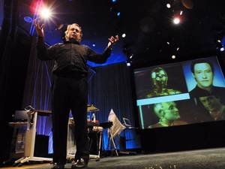[18:47](https://www.ted.com/talks/rodney_brooks_on_robots)

[Rodney Brooks](https://www.ted.com/speakers/rodney_brooks) [Robots will invade our lives](https://www.ted.com/talks/rodney_brooks_on_robots)

In this prophetic talk from 2003, roboticist Rodney Brooks talks about how robots are going to work their way into our lives — starting with toys and moving into household chores ... and beyond.

[Watch later](https://www.ted.com/session/new) · [72 comments](https://www.ted.com/talks/rodney_brooks_on_robots)

* [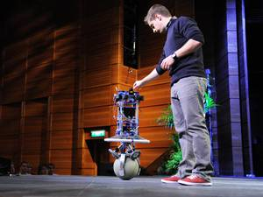5:16](https://www.ted.com/talks/peter_fankhauser_meet_rezero_the_dancing_ballbot)

[Péter Fankhauser](https://www.ted.com/speakers/peter_fankhauser) [Meet Rezero, the dancing ballbot](https://www.ted.com/talks/peter_fankhauser_meet_rezero_the_dancing_ballbot)

Onstage at TEDGlobal, Péter Fankhauser demonstrates Rezero, a robot that balances on a ball. Designed and built by a group of engineering students, Rezero is the first ballbot made to move quickly and gracefully — and even dance.

[Watch later](https://www.ted.com/session/new) · [99 comments](https://www.ted.com/talks/peter_fankhauser_meet_rezero_the_dancing_ballbot)

* 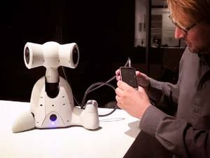[17:38](https://www.ted.com/talks/guy_hoffman_robots_with_soul)

[Guy Hoffman](https://www.ted.com/speakers/guy_hoffman) [Robots with "soul"](https://www.ted.com/talks/guy_hoffman_robots_with_soul)

What kind of robots does an animator / jazz musician / roboticist make? Playful, reactive, curious ones. Guy Hoffman shows demo film of his family of unusual robots — including two musical bots that like to jam with humans.

[Watch later](https://www.ted.com/session/new) · [129 comments](https://www.ted.com/talks/guy_hoffman_robots_with_soul)

* 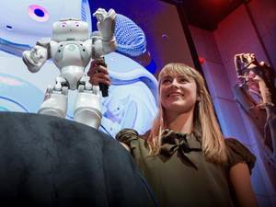[6:04](https://www.ted.com/talks/heather_knight_silicon_based_comedy)

[Heather Knight](https://www.ted.com/speakers/heather_knight) [Silicon-based comedy](https://www.ted.com/talks/heather_knight_silicon_based_comedy)

In this first-of-its-kind demo, Heather Knight introduces Data, a robotic stand-up comedian that does much more than rattle off one-liners — it gathers audience feedback (using software co-developed with Scott Satkin and Varun Ramakrishna at CMU) and tunes its act as the crowd responds. Is this thing on?

[Watch later](https://www.ted.com/session/new) · [110 comments](https://www.ted.com/talks/heather_knight_silicon_based_comedy)