Federal University of Pernambuco
Center of Informatics

Graduation in Computer Science

Experience in the systematic review of the literature on the studies about agile governance

Reynaldo Fabrinny Rodrigues Tibúrcio

Graduation Work

Recife
13 December 2011

Federal University of Pernambuco
Center of Informatics

Reynaldo Fabrinny Rodrigues Tibúrcio

Experience in the systematic review of the literature on the studies about agile governance

Dissertation submitted to the Center of Informatics of the Federal University of Pernambucoin partial fulfillment of requirements of degree of bachelor in computer science.

Coordenator: Alexandre Luna

Recife
13 December 2011

This work is dedicated to my Mother, my Father, my Sister
And my Friends wherever they are all around the world.

ACKNOWLEDGEMENTS

A special thanks to my the project coordenator Alexandre LUNA and to the professor Hermano Perelli which I’m glad that I had the chance to take a course a few years ago. I’m very greatfull with the chance that was given to me to join in this project.

A thanks to my friends and classmates Bruno Mihira, Diego Carlos, Rubem Rodrigues and Igor Dourado because without them, it would be impossible to finish this graduation. Without them, the nights that we spent here doing projects would have been colders and longers. I hope we don’t lost contact, and that we can keep this friendship.

Thanks to my father Reinaldo and my sister Gabrielly, thank you guys for your patiente, i know it wasn’t easy for you either, i can be a pain in the a** when I was worried with projects and tests.

I also would like to say thanks to my mother Marcia Rejane Rodrigues Pereira. Thank you for your effort during my last year in hight school, thank you for not let me give up from this course, thank you to give me the oportunity to do an exchange in France. Thank you very much for all the patience and the care with me for all this years. Without your support, today I wouldn’t be writing this document.

“Do not dwell in the past, do not dream of the future,
concentrate the mind on the present moment.”
Buddha

-I swear I’m trying.

Abstract

A systematic review is a way to perform comprehensive literature reviews on a non-tendentious way when there is a large amount of material available. For this porpouse, it must have an explicit selection criterion, in case other researchers can evaluate the quality of the review and even run it again.
This graduation project proposes to describe the experience of the author's participation in a systematic survey on governance agile.

Key words:

Agile Governance, Systematic Review, Experience

Table of Contents
Chapter 1 12
Introduction 12
Chapter 2 13
Corporate Governance - A Brief History 13
Agile Governance 14
Chapter 3 15
Metodology 15
Project Timeline 21
Chapter 4 22
The experience with the Automatic Search 22
First Results 24
Next Steps 24
Chapter 5 25
Conclusions 25
Apendix 26
How to convert BIB files into XML Files 26
References 29

Chapter 1

Introduction

Systematic reviews, including mapping, started in medicine, and is now are being used by several other areas of knowledge. Today they are appropriate in areas with a wide range of research, but whose main questions remain unanswered (PETTICREW &ROBERTS, 2006).

By performing a systematic Review we primarily seek to answer four questions: 'Why did you start?', 'What have you done?', 'What have you found?' And 'What does that mean anyway?' (Hill 1995). With great motivation to answer these questions, do a job in a transparent and credible way, we choose to do a systematic research, pioneer (so far there was no other mapping), on agile governance.

To review the literature is a very important step when thinking about starting a search because it is through it ​​that we contextualize our work within the area. But to do a good survey of existing studies is necessary, first of all, access to sources of reliable information. For this we use the network of the computer center at the Federal University of Pernambuco (UFPE), which has partnerships with major research bases and complete world.

The goal is that by the end of this systematic survey on governance agile our team has answered all survey questions and if it’s possible exchange experience with other research teams that are working in the same subject.

Chapter 2

Corporate Governance - A Brief History

Launched in the U.S. in the late 80s, early 90s, corporate governance only would be really widespread in the next decade. According to some authors such as Lodi (2000), corporate governance began to translate and protect the relationship between shareholders (especially minority), independent auditors and the company's executives, led by the board. It was the Cadbury Report (1992), published in England, which according to Lodi (2000), broadcast the first treatise on corporate governance around the world. The report was written with the aim of improving the performance of mainly European companies (especially the British) based on existing successful experiences in several American companies. Also according to Lodi, this report presents corporate governance as a system by which companies should be controlled and directed, as it gathers traces of the American model of governance.

Also in 1992, following the advice of Lodi, the foundation LENS was created in order to deploy a new management model aiming to better results and the consolidation of greater value to the company. The model was focused on, among others, the performance of the company shareholders which for the first time could monitor and analyze the performance of the organization's commitment to ethics and the wealth generation for the company and the community where they work. The Cadbury Report is a reference in the constitution and structuration of the Board, as well as the separation of the Executive Board, and in the basic guidelines for allocation of general administration of the company's Board of Directors.

Since 2001 has been a renewed interest in the subject of corporate governance,particularly due to the spectacular collapses of large U.S. corporations such asWorldcom and aEnron Corporation. In 2002, the U.S. federal government passed theSarbanes-Oxley Act, in order to restore public confidence in corporate governance in general.

Agile Governance

Today’s rapidly changing business environment shorten the average fortune 500 companies’ life span from 75 years to less than 15 years, only the most agile enterprise will survive and thrive.
As the needs of the business companies are dynamics to survive in the market they need agility in business (ROOSMALEN 2008). As consequences it’s TIC’s must be ready to evolve in order to adjust the environment and respond quickly with eficience to those changes.
Agile Governance is the set of behaviors, knowledge, skills, resources, methods, techniques and tools that will make possible the achievement and then maintain the strategic goals from the organization business through the continuous value delivery with guarantee and utility, being jointly owned by all sectors from the organization that is responsible for directing all involved in achieving strategic competitive advantages through the values ​​and principles of the agile manifesto which are:
- Good enough governance
- Business driven
- Human focus
- Based on quick Wins
- Systematic and adaptative approach
- Simple desing and continous refinement

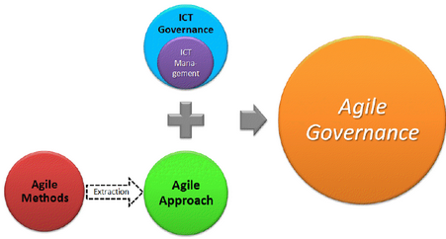
Figure 4 – Ilustration from the origin of Agile Governance

Chapter 3

Metodology

A systematic review can be divided into three main phases: planning the review, conduct the review and completion. The first phase is the most important step of the process, it is when the protocol that will be used to perform the review is defined. This chapter will describe the protocol created by our team to this systematic review.
What is the state of the art Agile Governance in the world? It's the answer to that question that we aim to find by the end of this project.
In our quest to find the state of the art, we hope to find the answer for some secondary questions. These questions are called, specific research questions and they are responsible to keep us in the right track to achieve our goal.`
So in the protocol were defined the following specific research questions:
RQ1: Has behaved as the domain of agile governance in the world?
RQ2: What are the works and initiatives in this domain?
RQ3: Who authors and which research groups has published about this theme?
RQ4: How this domain is applied in the organizations?
RQ5: How this impacts people's lives and organization businesses?
The second step, once defined the issues that motivate and give to the study objectives is to define the criteria for inclusion and exclusion of studies in the research.
The criteria for inclusion and exclusion are important because they will keep the study focused on those data that are relevant to answer the specific questions thus excluding non-relevant work. It is what will maintain the study's focus, despite the huge amount of results in searches.
For our mapping were defined the following inclusion and exclusion criteria:
The following types of studies will be excluded:
- Studies not written in English.
- Invited papers, tutorials, key-note speech, workshop reports, theses, dissertations, technical reports,Articles expressing personal viewpoints or opinions.
- Documents that are not full papers (eg PowerPoint presentation or extended abstract).
- Studies related to computer science that are not clearly the area of ​​Software Engineering or Information Systems.
- Articlespublished after 31/12/2010

The following types of studies are included:
Complete articles published in reviewed journals or conferences;
- Scientific studies that address your goals / hypotheses / research questions the paradigm of Agile Governance;
- Scientific studies which analyze in its results Agile Governance.

In the case of a single study have been published in more than one journal / conference, the two versions of the study should be considered and reviewed for the purpose of data extraction, and the first publication will be used in all data analysis.
An initial scoping study was used to determine the search strategy, wich was the third step in the protocol's developmet. The search strategy was responsible for guiding us during the second phase of the review. The search strategy is intended to identify and retrieve the entire population of publications that meets the eligibility criteria. In the search strategy we also defined which engines we would use and the strings for each one of them.

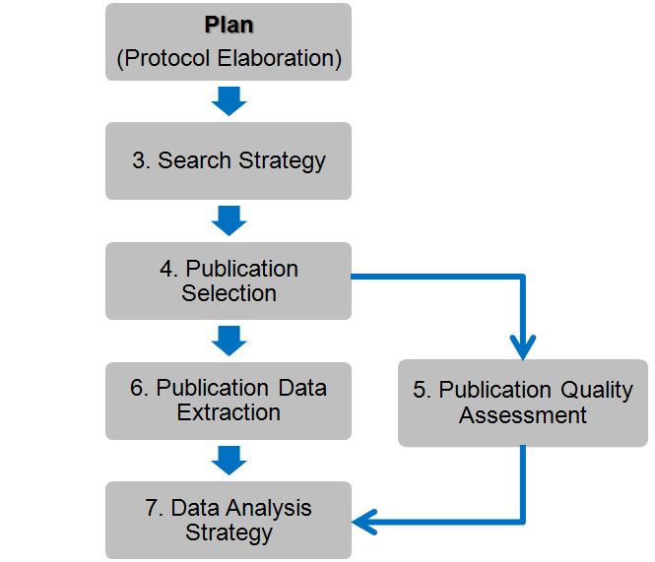
Figura 1 – Systematic Review Process
The Figure 1 show the entire Systematic Review Process adopted in this research.

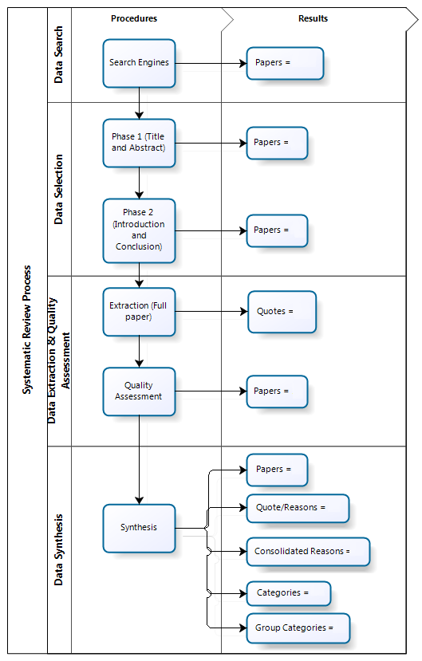
Figure 2- Systematic Review Results
The Figure 2 shows the process fases and the articles generated in each one of this fases.
With the strategy and criteria that include or exclude items defined, we can start to decide which strings we will use in the research. To choose the strings is harder task since it is necessary to choose the words to account for possible synonyms that serve the context. So eventually during our data collection our string needed to be changed so more relevant articles could be captured and the less relevant excluded.
In Tables 1 and 2 are shown Strings and their synonyms that were used in searches. And in Tables 3 and 4 we manipulated these strings to obtain the "sentences" that were used in the final engines.
Table1 - Terms for the construction of the search string - Version 1
Identified Terms | Terms to be used
Governance | - governance  - governing  - government  - government activity  - administration  - govern  - organization  - compliance  - regulatory aspects  - SOX  - Sarbanes Oxley  - Basel  - business process  - business driven  - IT management  - information technoloy management  - ICT management  - information and communication Technologies management | - service management  - ITIL  - COBIT  - IT Flex  - BSC  - COSO  - e-SCM  - ISO/IEC 20000  - MAnGve  - information system  - audit system  - security information  - service strategy  - service design  - service transition  - service operation  - continual service improvement  - project management
Agile | - agile  - agility  - lean  - quick win | - adaptative  - flexible  - good enough  - simple design

Source: Self creation

Table 2 – Terms for the construction of the search string – Version 2
Identified Terms | Terms to be used
Governance | - governance | - service management
Agile | - agile | - lean

Source: Self creation
Thus, the search string was built based on the combination of the terms found (available in the table above), which were concatenated using the Boolean operators "OR" and "AND".
- String for “governance” (v2):
"governance" OR "service management"
- String for “agile” (v2):
"agile" OR "lean"
Table 3 – The search string version 1
Search String – v1
("governance" OR "service management") AND ("agile" OR "lean")

Table 4 – The search String version 2
Search String – v2
("governance" OR "service management") AND ("agile" OR "lean") AND (“agility”)

Finally it was decided to search engines that would be used. For automated queries, we decided that the search engines that would be used should meet the following criteria:

- Access to consulting studies through the internet;
- Importance and relevance of research source.

Following these criteria, the following engines were selected for the automatic search:

Table 5 – The automatic search engines
 | ENGINES | SITES
1 | ACM Digital library | http://portal.acm.org/
2 | Scirus | http://www.scirus.com/
3 | IEEE Xplore Digital Library | http://ieeexplore.ieee.org/
4 | ISI Web of Science | http://apps.isiknowledge.com/
5 | ScienceDirect | http://www.sciencedirect.com/
6 | Scopus | http://www.scopus.com/
7 | SpringerLink | http://www.springerlink.com/
8 | Google Scholar | http://scholar.google.com/
9 | Google PDF Documents | http://www.google.com

The other search type that is used is the manual search. The team responsible for this kind of search should go to the site of the journals and manually access each of the years of publication, volumes and issues by reading the titles, abstracts and keywords. Discarded (without documentation) studies judged to be clearly irrelevant to the search. Those that are included should be documented.
With the assistance of an expert in the field of software engineering, it was decided that a manual search in journals will be made from the following sources:

Table 6 – Manual Search Engines
Title | SITE
Information and Software Technology | http://www.informatik.uni-trier.de/~ley/db/journals/infsof/
Journal of Management & Governance | http://www.springer.com/business+%26+management/business+for+professionals/journal/10997
Governance: An International Journal of Policy, Administration and Institutions | http://www.wiley.com/bw/journal.asp?ref=0952-1895  http://www.sog-rc27.org/Governance/journal.htm
Governance International Monthly Newsletter | http://www.governance.co.uk/index.htm
JISTEM Journal of Information Systems and Technology Management | www.jistem.fea.usp.br
Journal of Administration & Governance | http://www.joaag.com/Home_Page.php
International Journal of Disclosure and Governance | http://www.palgrave-journals.com/jdg/index.html
Information & Management | http://ees.elsevier.com/infman
International Journal of Disclosure and Governance | http://www.jbsge.vu.edu.au/
ResearchGate professional scientific network | http://www.researchgate.net/

After all the required settings, it was started the second phase of the project, the search stage. For this, the team was divided into two pairs where the author of this work was allocated in the pair responsible for performing the automatic searches.

Project Timeline

The folowing timeline shows the graduation project dates, which includes some of the dates from the systematic review project.

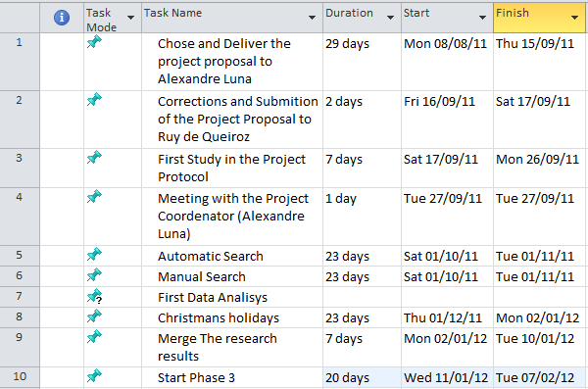
Figure 3 – Graduation project timeline

Chapter 4

The experience with the Automatic Search

To better explain how this phase works, it was divided into three steps: search, capture and conversion and unification of data. To validate the experiment, it was agreed that these stages should be carried out sequence, this means that a person can only move to the next phase after completion of the previous one in each engine at a time.
In the first stage (searches) for each engine, we inserted the search string in the advanced search field and also all the previously defined criteria (such as deadlines).
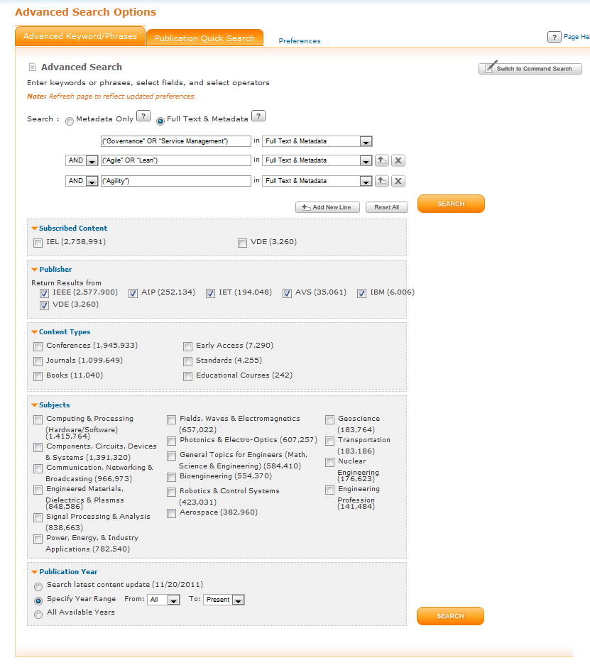
Figure 3 – Search (first step) from IEEE Xplore Digital Library’s engine

After performing the search begins the longest phase, depending on the engine, which is the stage of capture. It is this phase when all the search results should be exported. Depending on the engine, each result must be manually selected to be exported (which makes this one of the most time consuming step of the review). The format in which the file is exported also varies from engine to engine, the most common formats are: BIB, XLS/ XLSX And RIS.
The last phase of this step is the conversion and unification of data where all the files saved in formats other than excel must be converted and combined into a single spreadsheet. In order to convert the files BIB to the XLS format the bib2endnote.jar software was used.

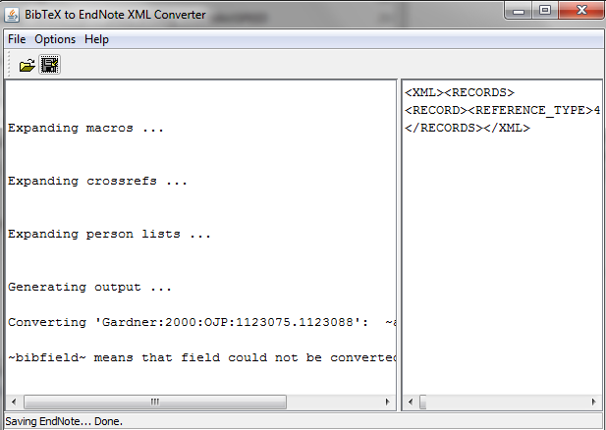
Figure 4 – The bib2endnote.jar software
Upon completion of the data collection from the engine, step-by-step from the data collection must be documented in the protocol document. This serves to validate the form of the data was obtained.
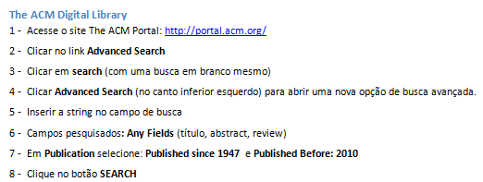
Figure 5 – Description step-by-step from the ACM engine (In Portuguese).

First Results

After collecting on the automatic engines, first obtained as a result, the table below

Table 7 – Table showing the engines and it’s results from the automatic search.
Engine | Quantity
1. ACM Digital library | 275
2. Scirus | 185
3. IEEE Xplore Digital Library | 189
4. ISI Web of Science | 92
5. ScienceDirect | 237
6. Scopus | 343
7. SpringerLink | 296
8. Google Scholar | 132
9. Google PDF Documents | 240

This table gives an initial idea of ​​the magnitude of the initial amount of articles that we are dealing with. Initial because the project's next step is, to do a comparative analysis with the results from each engine to exclude possible items that are present in the results of more than one engine.

Next Steps

As already shown in figure 1, which describes the protocol adopted in this review, as a next step we must integrate the tables containing the results of the automatic search and eliminate redundancies, by the end of this task we can then initiate the texts analysis phase.

Chapter 5

Conclusions

The fact that this monograph has been written before the conclusion of the systematic review precludes a complete description of the review work itself. However, based on past experience, we can make the following analysis:
So far in the research, we have an order of magnitude of 250 articles per engine (numbers from the automatic search). After eliminating duplicated articles, perform the first screening by reading the titles and abstracts, we should have around 1500 articles to read through.
To be participating in a systematic review is not an easy job, it requires focus and dedication. This all not to put in risk the credibility of research, have validated the work at the end and have the questions that motivate the work, answered. It is an important and necessary step for those who want to work with research and that's why this learning opportunity has been very valuable and instructive.

Apendix

How to convert BIB files into XML Files

Step 1
By using the software bib2endnote.jar (Figure 4), convert the bibTex to an XML file.

The software can be downloaded from the url http://www.findthatfile.com/search-4786718-hZIP/winrar-winzip-download-bib2endnote-jar.htm.

Step 2

Select the bib file and save it as a XML file.

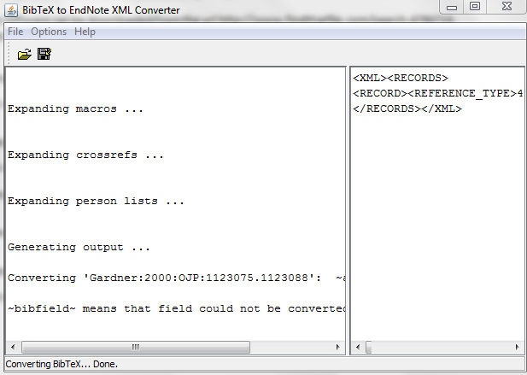

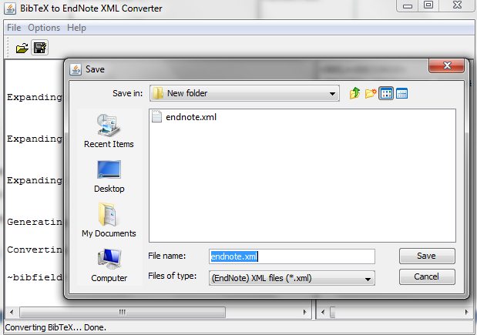

Step 3

Edit this file with the notepad and save it using the encoding UNICODE.

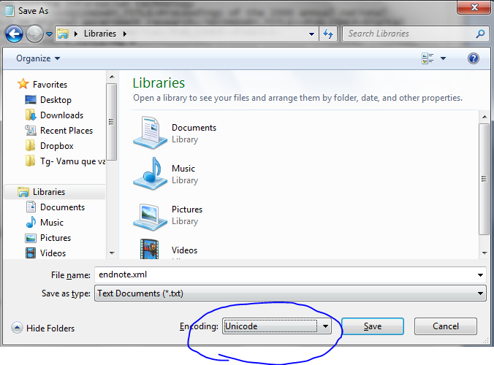

Step 4

Open the XML in MS Excel

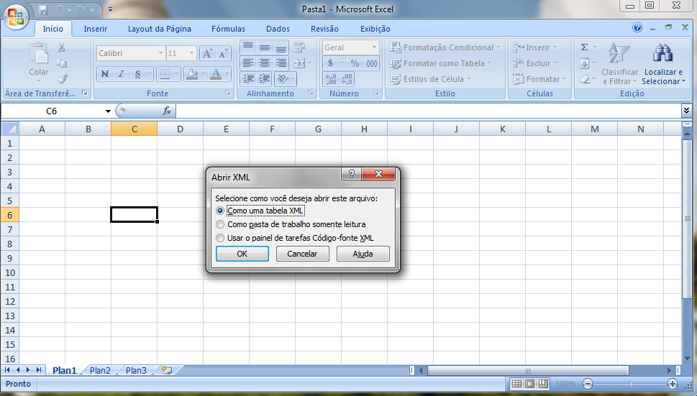

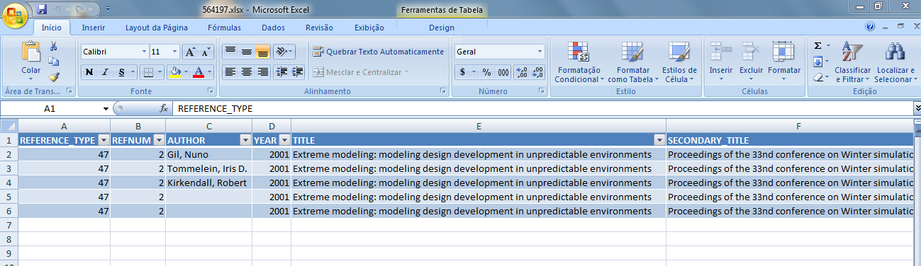

Step 5

Adjust the Lines, there will be one for each author.

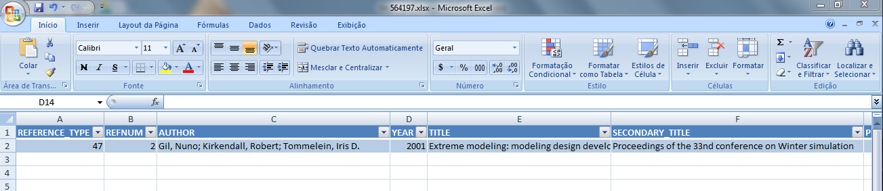

Step 6

Save it as xml/xmls file.

References
GOVERNANÇA CORPORATIVA & ÉTICA NAS ORGANIZAÇÕES. (dezembro de 2008). Fonte: REVISTA MULTIDISCIPLINAR DA UNIESP: http://www.uniesp.edu.br/revista/revista6/pdf/10.pdf
Luna, A. (20 de 11 de 2011). GP2_Agile Governance Management Model_meeting_ajhol_Publicado.pdf. Fonte: MAnGve: http://www.mangve.org/downloads/GP2_AgileGovernanceManagementModel_meeting_ajhol_Publicado.pdf?attredirects=0&d=1
Luna, A. J., Batista, F. S., Nascimento, R. M., & Fabrinny, R. (2011). Prococol_AgileGovernance(Until2010)_V0.11.
Luna, A. J., Costa, C. P., Moura, H. P., Novaes, M. A., & Nascimento, C. A. (2010). AGILE GOVERNANCE IN INFORMATION AND COMMUNICATION TECHNOLOGIES: SHIFTING PARADIGMS. Journal of Information Systems and Technology Management .
Luna, A. (s.d.). MAnGve. Fonte: MAnGve: http://www.mangve.org/

